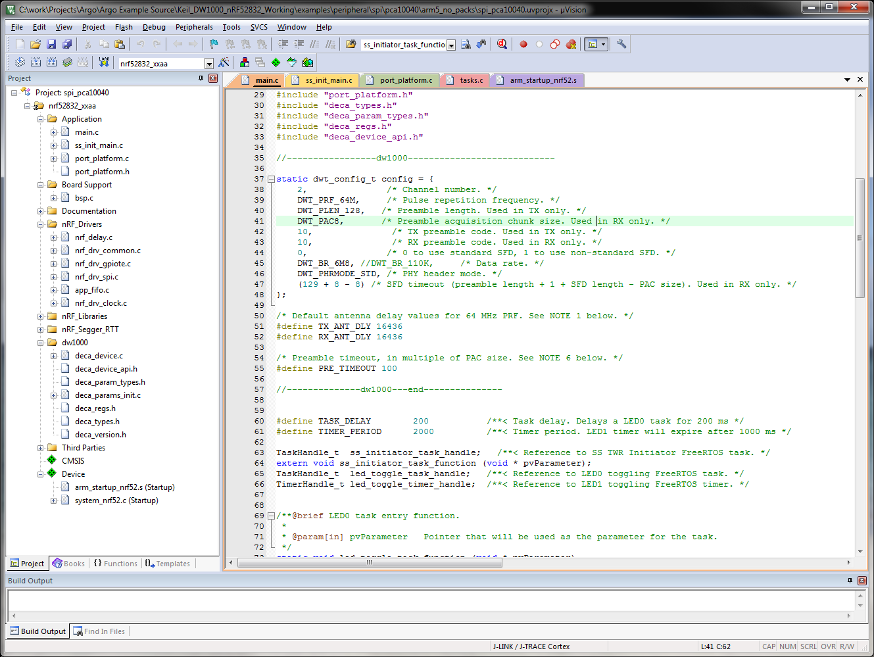

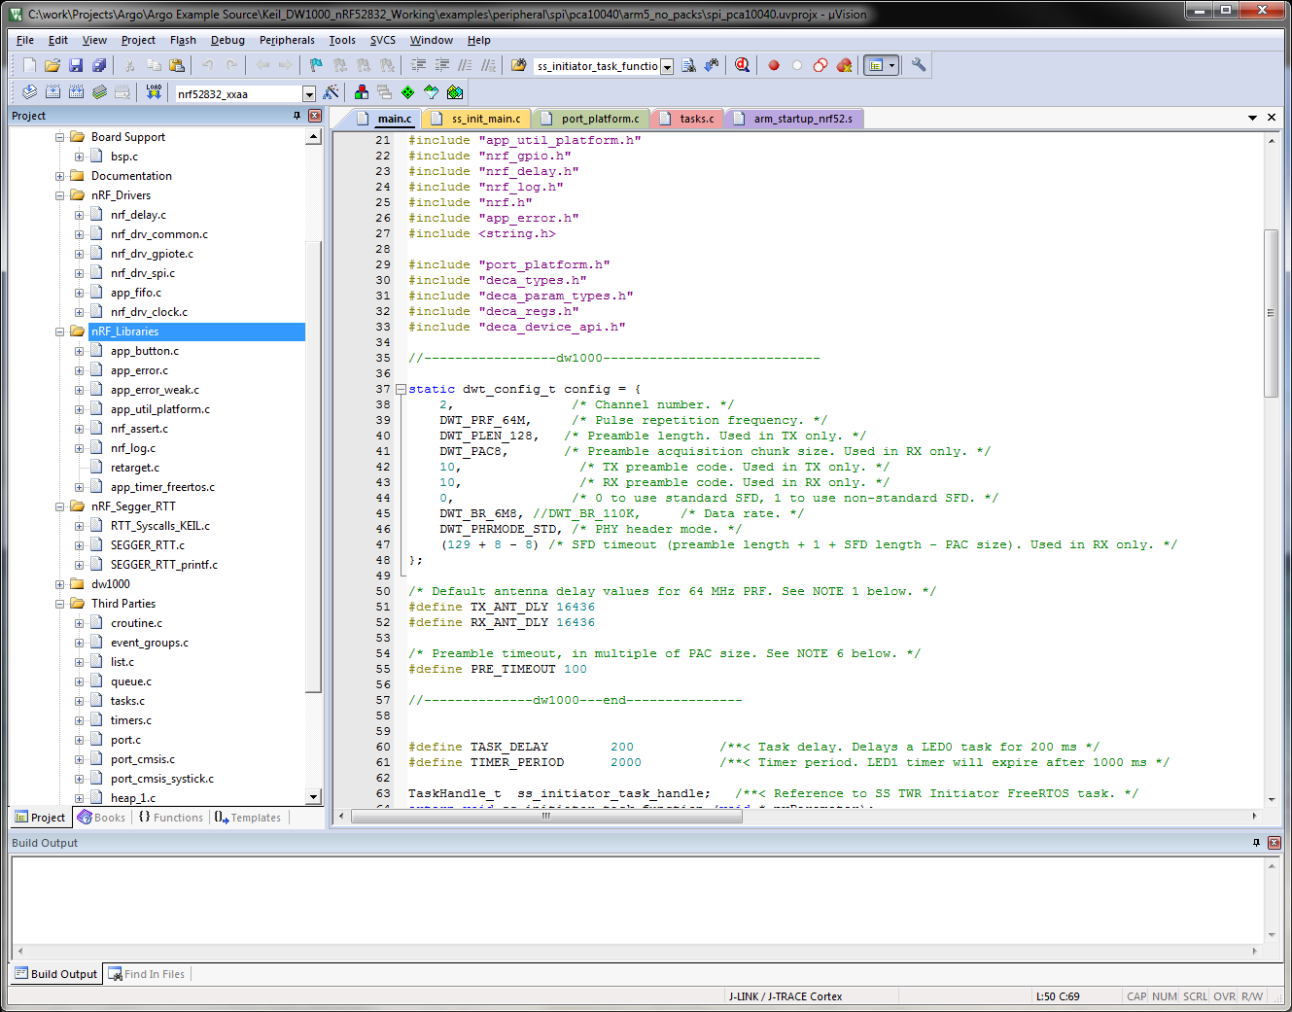

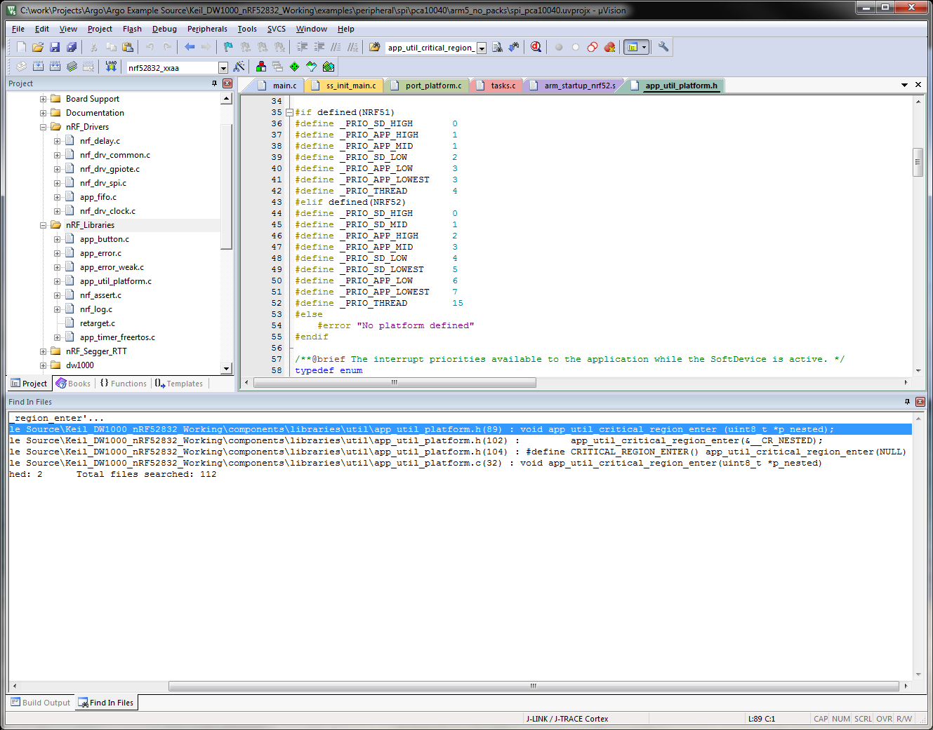

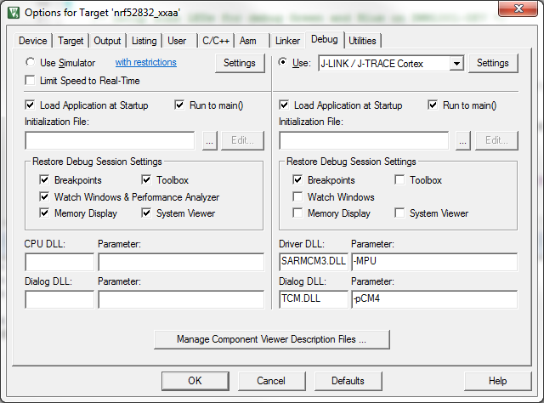

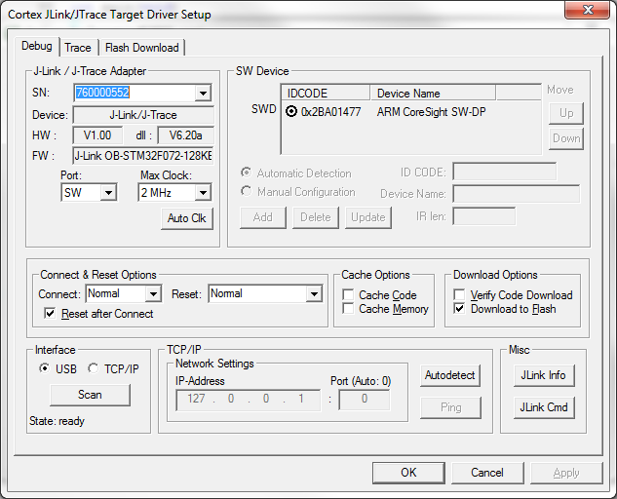

* 2MHz clock setup important.

Load "C:\\work\\Projects\\Argo\\Argo Example Source\\Keil_DW1000_nRF52832_Working\\examples\\peripheral\\spi\\pca10040\\arm5_no_packs\\_build\\nrf52832_xxaa.axf"

Set JLink Project File to "C:\work\Projects\Argo\Argo Example Source\Keil_DW1000_nRF52832_Working\examples\peripheral\spi\pca10040\arm5_no_packs\JLinkSettings.ini"

* JLink Info: Device "NRF52832_XXAA" selected.

JLink info:

------------

DLL: V6.20a, compiled Sep 15 2017 18:04:38

Firmware: J-Link OB-STM32F072-128KB-CortexM compiled May 4 2017 14:43:23

Hardware: V1.00

S/N : 760000994

* JLink Info: Found SW-DP with ID 0x2BA01477

* JLink Info: Found SW-DP with ID 0x2BA01477

* JLink Info: Scanning AP map to find all available APs

* JLink Info: AP[2]: Stopped AP scan as end of AP map has been reached

* JLink Info: AP[0]: AHB-AP (IDR: 0x24770011)

* JLink Info: AP[1]: JTAG-AP (IDR: 0x02880000)

* JLink Info: Iterating through AP map to find AHB-AP to use

* JLink Info: AP[0]: Core found

* JLink Info: AP[0]: AHB-AP ROM base: 0xE00FF000

* JLink Info: CPUID register: 0x410FC241. Implementer code: 0x41 (ARM)

* JLink Info: Found Cortex-M4 r0p1, Little endian.

* JLink Info: FPUnit: 6 code (BP) slots and 2 literal slots

* JLink Info: CoreSight components:

* JLink Info: ROMTbl[0] @ E00FF000

* JLink Info: ROMTbl[0][0]: E000E000, CID: B105E00D, PID: 000BB00C SCS

* JLink Info: ROMTbl[0][1]: E0001000, CID: B105E00D, PID: 003BB002 DWT

* JLink Info: ROMTbl[0][2]: E0002000, CID: B105E00D, PID: 002BB003 FPB

* JLink Info: ROMTbl[0][3]: E0000000, CID: B105E00D, PID: 003BB001 ITM

* JLink Info: ROMTbl[0][4]: E0040000, CID: B105900D, PID: 000BB9A1 TPIU

* JLink Info: ROMTbl[0][5]: E0041000, CID: B105900D, PID: 000BB925 ETM

ROMTableAddr = 0xE00FF000

* JLink Info: Reset: Halt core after reset via DEMCR.VC_CORERESET.

* JLink Info: Reset: Reset device via AIRCR.SYSRESETREQ.

Target info:

------------

Device: nRF52832_xxAA

VTarget = 3.300V

State of Pins:

TCK: 0, TDI: 0, TDO: 1, TMS: 1, TRES: 1, TRST: 1

Hardware-Breakpoints: 6

Software-Breakpoints: 8192

Watchpoints: 4

JTAG speed: 2000 kHz

Full Chip Erase Done.

Programming Done.

Verify OK.

* JLink Info: Reset: Halt core after reset via DEMCR.VC_CORERESET.

* JLink Info: Reset: Reset device via AIRCR.SYSRESETREQ.

Application running ...

Flash Load finished at 11:12:21

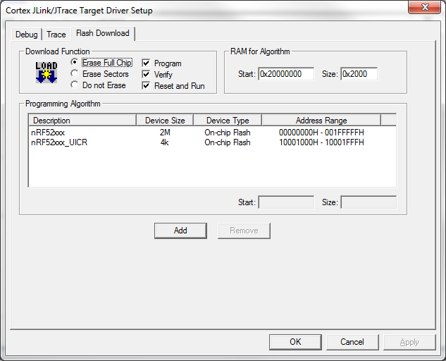

*Erase Full Chip ****